OFFICE OF THE CONTROLLER OF EXAMINATIONS
Rabindranath Tagore University

NOTICE
Dated-03-02-2023

PG Examinations, 2023
This is for information to all concerned that Post Graduate 1ST and 3rd Semester Examination, 2023 will be held tentatively from 22nd of February 2023.

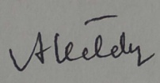
(Dr. A. Kataky)
Controller of Examinations i/c
Rabindranath Tagore University

