

OFFICE OF THE REGISTRAR
RABINDRANATH TAOGRE UNIVERSITY::HOJAI
HOLIDAY LIST FOR THE PERIOD OF 1ST JANUARY, 2021 TO 31ST DECEMBER, 2021 FOR THE CALENDAR YEAR 2021
(As approved by the Hon’ble Vice-Chancellor on dated 01.01.2021)
Holidays: Offices & Classes of the university will remain closed on the following day’s w.e.f. 1st January 2021 to 31st December, 2021.

Sl Nos. | Occasions | Month | Date(s) | Day(s)of the week | No. of days
1 | Magh Bihu | January | 12 to 16 | Tuesday to Saturday | 5
2 | Silpi Divas | January | 17 | Sunday | 1
3 | Netaji’s Birthday | January | 23 | Saturday | 1
4 | Republic Day | January | 26 | Tuesday | 1
5 | Saraswati Puja | February | 16 | Tuesday | 1
6 | Sivaratri | March | 11 | Thursday | 1
7 | Dol Jatra | March | 28&29 | Sunday & Monday | 2
8 | Good Friday | April | 2 | Friday | 1
9 | Bohag Bihu | April | 13 to 17 | Tuesday to Saturday | 5
10 | Sati Sadhini Divas | April | 21 | Wednesday | 1
11 | May Day | May | 1 | Saturday | 1
12 | Id-UL-Fitre | May | 14 | Friday | 1
13 | Buddha Purnima | May | 26 | Wednesday | 2
14 | Summer Vacation | July | 1 to 31 | Wednesday to Friday | 31
15 | Id-UL-Zuha | July | 21 | Wednesday | 1
16 | Independence Day | August | 15 | Sunday | 1
17 | Tithi of Sri Sri Madhabdeva | August | 27 | Friday | 1
18 | Janmastomi | August | 30 | Monday | 1
19 | Tithi of Srimanta Sankardeva | September | 8 | Wednesday | 1
20 | Birthday of Mahatma Gandhi | October | 2 | Saturday | 1
21 | Durga Puja, Janmotsav of Srimanta Sankardeva,  Kati Bihu & Lakshmi Puja | October | 12 to 20 | Tuesday to Wednesday | 9
22 | Kali Puja & Dipawali | November | 4 & 5 | Thursday and Friday | 2
23 | Guru Nanak’s Birthday | November | 19 | Friday | 1
24 | Lachit Divas | November | 24 | Wednesday | 1
25 | Asom Divas( Su-Ka-Pha Divas) | December | 2 | Thursday | 1
26 | Christmas Day | December | 25 | Saturday. | 1
27 | Winter Break | December | 26th Dec to 1st Jan,2022 | Sunday to Saturday | 7

Restricted Holidays: Each employee will also be entitled to avail himself/herself of any 2(two) holidays in the year to be chosen by him/her out of the following list of restricted holidays. The employee(s) intending to avail this holiday should submit application to the concerned head for approval of the competent authority in advance. Such leave will normally be granted by the leave sanctioning authority except when the presence of the employee(s) is considered necessary due to exigencies work in the university.

Sl Nos | Occasions | Month | Date(s) | Day(s)of the week | No. of days
1 | New Year Day | January | 1 | Friday | 1
2 | Gwther Bathou San | January | 26 | Tuesday | 1
3 | Me-Dum-Me-Phi | January | 31 | Sunday | 1
4 | Ali Aye Lingang | February | 17 | Wednesday | 1
5 | Bir Chilarai Divas | February | 27 | Saturday | 1
6 | Baithow Puja/khring khring Baithow puja | March | 22 | Monday | 1
7 | Shab-E-Barat | March | 30 | Tuesday | 1
8 | Tithi of Gopal Deva | April | 18 | Sunday | 1
9 | Mahabir Jayanti | April | 25 | Sunday | 1
10 | Tithi of Damodar Dev | May | 12 | Wednesday | 1
11 | Janmotsav of Sri Sri Madhab Dev | May | 27 | Thrusday | 1
12 | Tithi of Hari Dev | June | 10 | Thrusday | 1
13 | Death of Bishnu Prasad Rabha | June | 20 | Sunday | 1
14 | Muharram | August | 20 | Friday | 1
15 | Biswakarma Puja | September | 17 | Friday | 1
16 | Fateha-E-Dwaz Daham | October | 19 | Thursday | 1
17 | Bhai Dooj/ Bhai Tika | November | 6 | Saturday | 1
18 | Chhat Puja | November | 10 | Wednesday | 1
19 | Martyr’s Day | December | 10 | Friday | 1
20 | Christmas Eve | December | 24 | Friday | 1

Observance Day:

Sl Nos. | Occasions | Month | Date(s) | Day(s)of the week
1 | Silpi Divas | January | 17 | Sunday
2 | Saraswati Puja | February | 16 | Tuesday
3 | Rabindra Jayanti | May | 9 | Sunday
4 | University Foundation Day | June | 1 | Tuesday
5 | World Environment Day | June | 5 | Saturday
6 | Tithi of Sri Srimanta Sankardev | September | 8 | Wednesday
7 | Death Anniversary of Dr. Bhupen Hazarika | November | 5 | Friday

Note: 1) If any Holidays for occasions do not fall on the days notified, necessary notification, changing the date will be issued in due course.
2) Additional holidays further to the above will be applicable as when declared by the University Administration.
3) Any other days as may be declared by the State Govt/Dist. Admn. Under Section 25 of the Nagotiable Instruments Act, 1888 (XXIV of
1981) as holidays will be observed.
4) The exact date of Ambubasi Nibriti will depend on the next Assamese new calendar which is not available now.
- University shall remain closed on 3rd Saturday of Every month.

Ref.No.RTU/holiday/

Copy forwarded for information and necessary action to:-

- All heads of the Teaching Departments, Rabindranath Tagore University.
- All Heads of the Administrative Departments, Rabindranath Tagore University.
- The Secretary, Board of Secondary Education, Assam, Guwahati-21.
- The Secretary, Assam Higher Secondary Education Council, Guwahati-21.
- The Secretary to the Governor of Assam, Raj Bhawan, Guwahati-1.
- The Secretary to the Govt. of Assam, education Department, Guwahati-6.
- The Director of Higher Education, Assam, Guwahati-19.
- The Director of Medical Education, Assam, Dispur, Guwahati-6.
- The Secretary, University Grant Commission, Bahadur Shah Zafar Marg, New Delhi-110002
- The Director of Technical Education, Assam, Guwahati-19
- The Secretary, Association of Indian Universities, A.I.U., 16 Kotla Marg, New Delhi-110002
- The Secretary to the Vice-Chancellor, Rabindranath Tagore University.
- The Secretary to the Registrar, Rabindranath Tagore University.
- University Website.

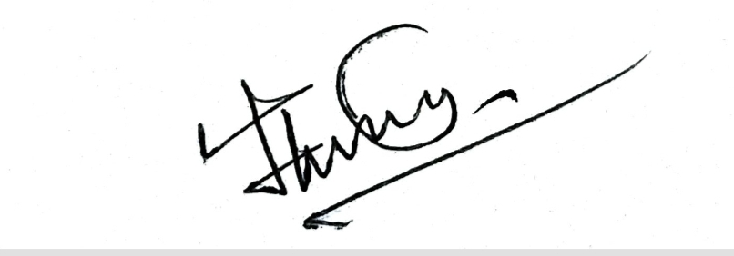

Registrar

Rabindranath Tagore University

